

Mawlana Bhashani Science and Technology University

Lab-Report

Lab Report No: 06
Lab Report Name: Linux command for process
Course code: ICT-3110
Course title: Operating System Lab
Date of Performance:
Date of Submission:

Submitted by Submitted To
Name : Maskur Al Shal Sabil
ID: IT 18021
3rd year 1st semester
Session : 2017-2018
Dept of ICT
Nazrul Islam
Assistant Professor
Dept. of ICT,
MBSTU.

Lab Report No-06: Linux command for process
Process Management :
An instance of a program is called a Process. In simple terms, any command that we give to our Linux machine starts a new process. The Linux terminal has a number of useful commands that can display running processes, kill them, and change their priority level. When we launch Office to write some thing corresponding processes is created .Having multiple processes for the same program is possible.
This lab report lists the classic, traditional commands, as well as some more useful, modern ones to mange process.

Process commands in Linux :

top
The top command is the traditional way to view your system’s resource usage and see the processes that are taking up the most system resources. Top displays a list of processes, with the ones using the most CPU at the top.
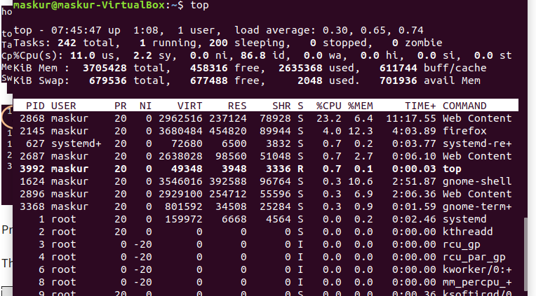

To exit top or htop, use the Ctrl-C keyboard shortcut. This keyboard shortcut usually kills the currently running process in the terminal. Also we can press ‘q’ on the keyboard to move out of the process display.
The terminology is as follows :

Field | Description | Example 1 | Example 2
PID | The process ID of each task | 2868 | 2145
User | The username of task owner | maksur | maskur
PR | Priority Can be 20(highest) or -20(lowest) | 20 | 20
NI | The nice value of a task | 0 | 0
VIRT | Virtual memory used (kb) | 2962516 | 3680484
RES | Physical memory used (kb) | 237124 | 454820
SHR | Shared memory used (kb) | 78928 | 89944
S | Status  There are five types:  'D' = uninterruptible sleep  'R' = running  'S' = sleeping  'T' = traced or stopped  'Z' = zombie | S | S
%CPU | % of CPU time | 23.2 | 4.0
%MEM | Physical memory used | 6.4 | 12.3
TIME+ | Total CPU time | 11:17.55 | 4:03.89
Command | Command name | Web Content | firefox

htop
The htop command is an improved top. It’s not installed by default on most Linux distributions — here’s the command we’ll need to install it on Ubuntu:
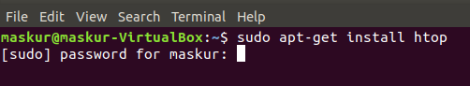
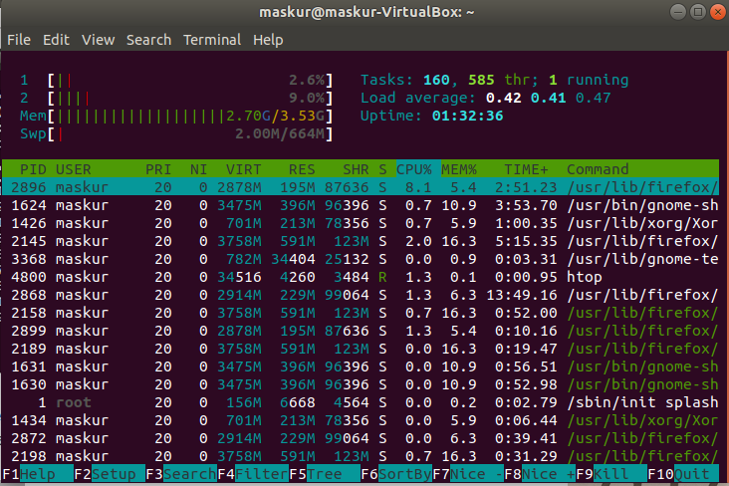
Once installed, just type htop at a terminal to launch it, and notice the great text-mode graph at the top of the display:

But here’s the best part… just use Our Up/Down arrow keys to select a process, and then we can kill it with the F9 key if we’d like, or we can change the priority by using the F7 and F8 keys. (note that we’ll have to be root to give anything really high priority).

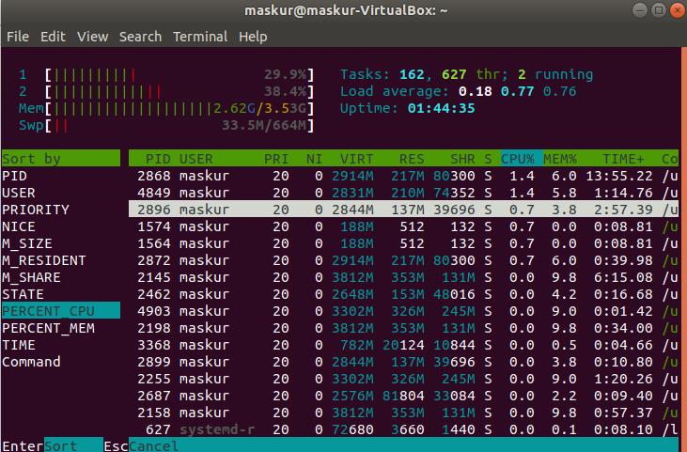
We can use the F6 key to change the default sort column really easily :
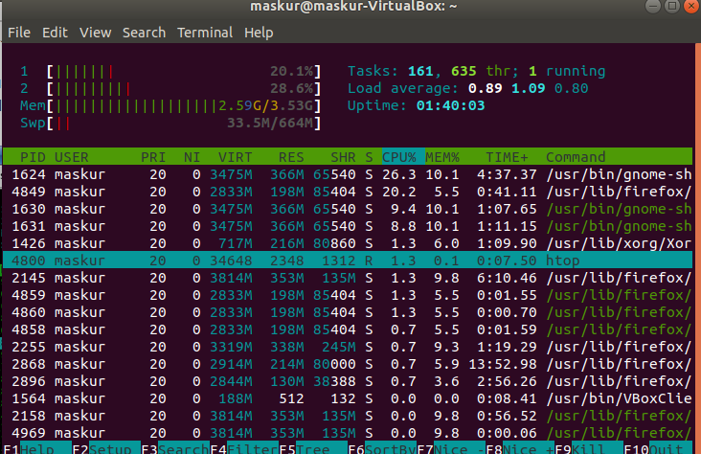

PS
This command stands for 'Process Status'. It is similar to the "Task Manager" that pop-ups in a Windows Machine when we use Cntrl+Alt+Del. This command is similar to 'top' command but the information displayed is different.
To check all the processes running under a user, use the command -
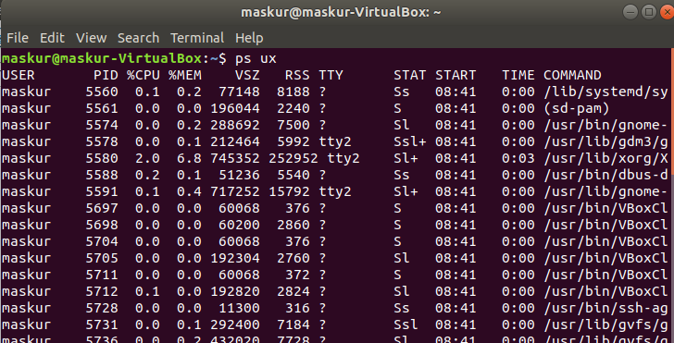

pstree
The pstree command is another way of visualizing processes. It displays them in tree format. So, for example, Our X server and graphical environment would appear under the display manager that spawned them.
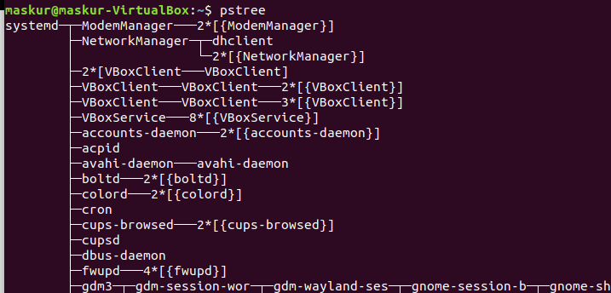

kill
The kill command can kill a process, given its process ID. You can get this information from the ps -A, top or pgrep commands.
Kill pid
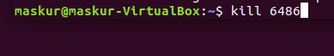

pgrep
Given a search term, pgrep returns the process IDs that match it. For example, you could use the following command to find Firefox’s PID:
pgrep firefox

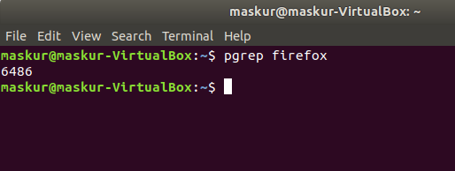

pkill & killall
The pkill and killall commands can kill a process, given its name. Use either command to kill Firefox:
pkill firefox
killall firefox

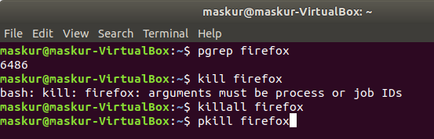
renice
The renice command changes the nice value of an already running process. The nice value determines what priority the process runs with. A value of -19 is very high priority, while a value of 19 is very low priority. A value of 0 is the default priority.
The renice command requires a process’s PID. The following command makes a process run with very low priority:
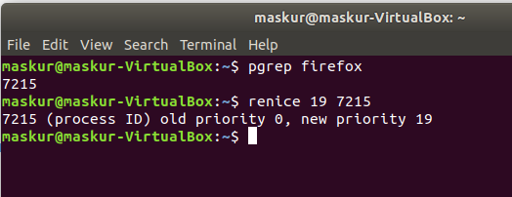

xkill
The xkill command is a way of easily killing graphical programs. Run it and your cursor will turn into an x sign. Click a program’s window to kill that program. If you don’t want to kill a program, you can back out of xkill by right-clicking instead.
